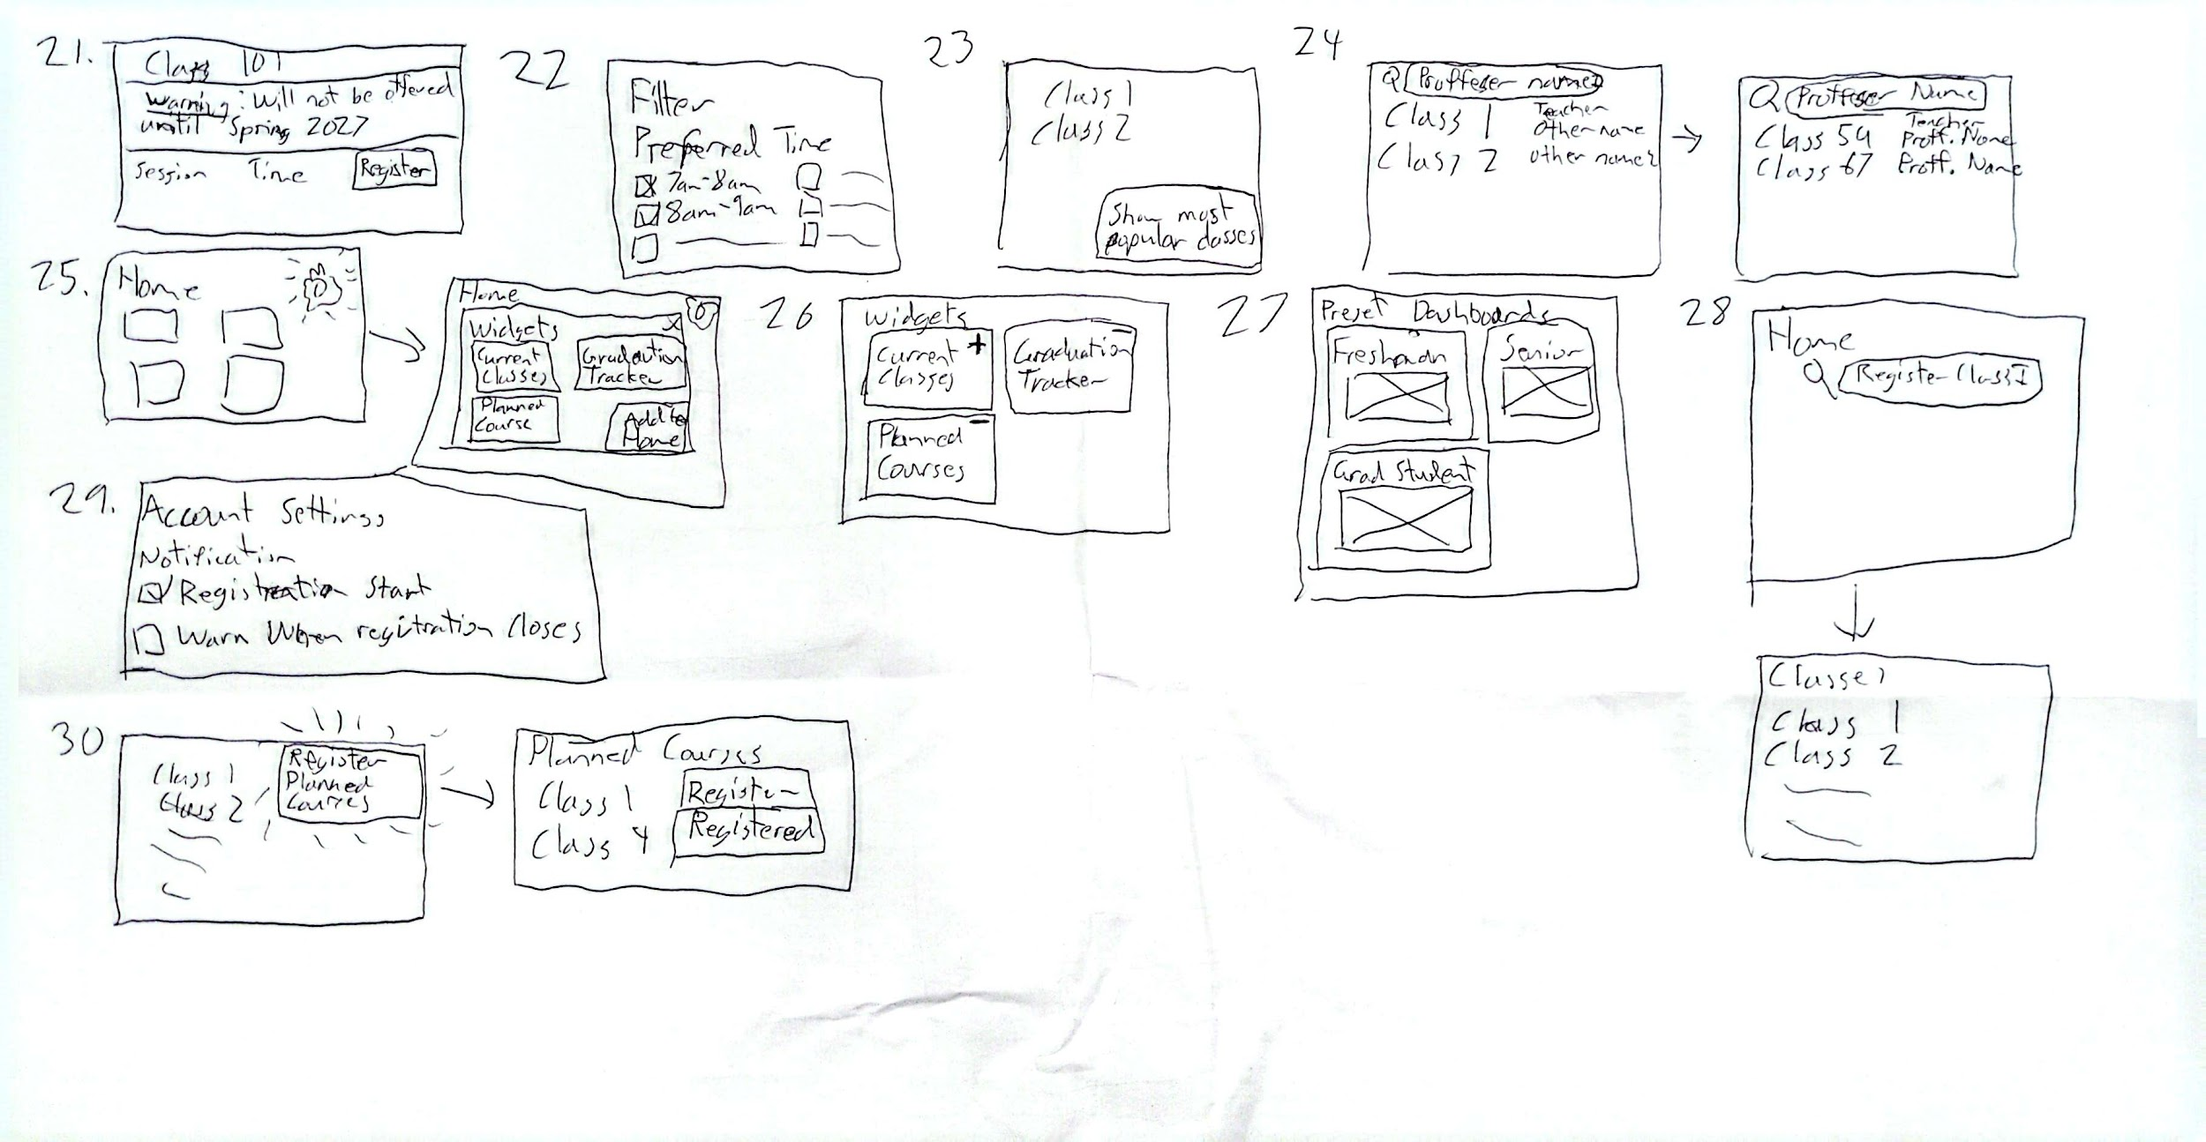
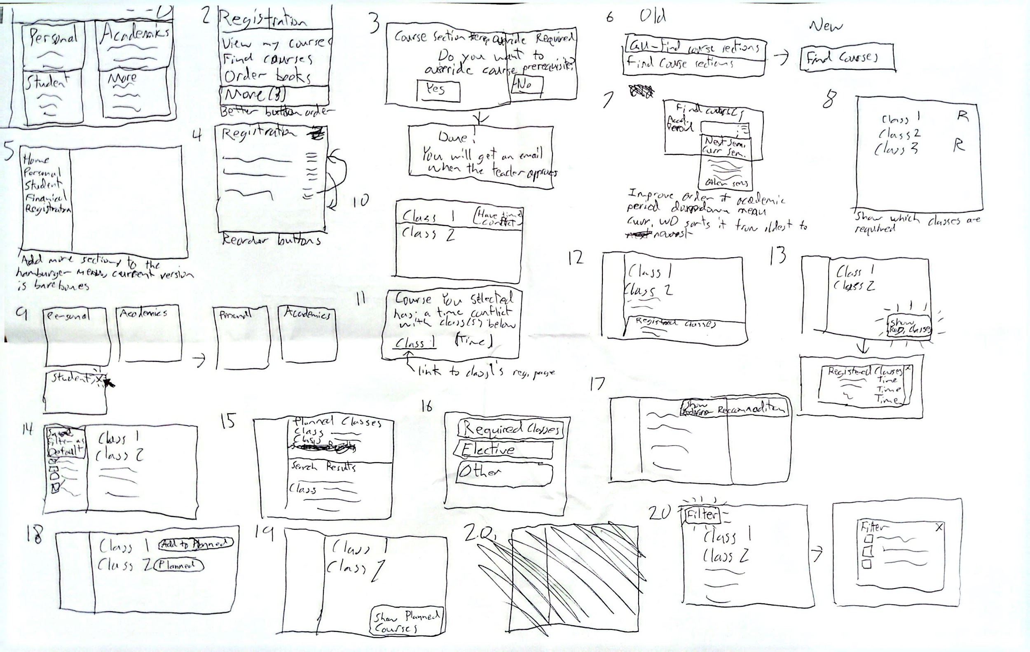
Part 1: 30 Sketches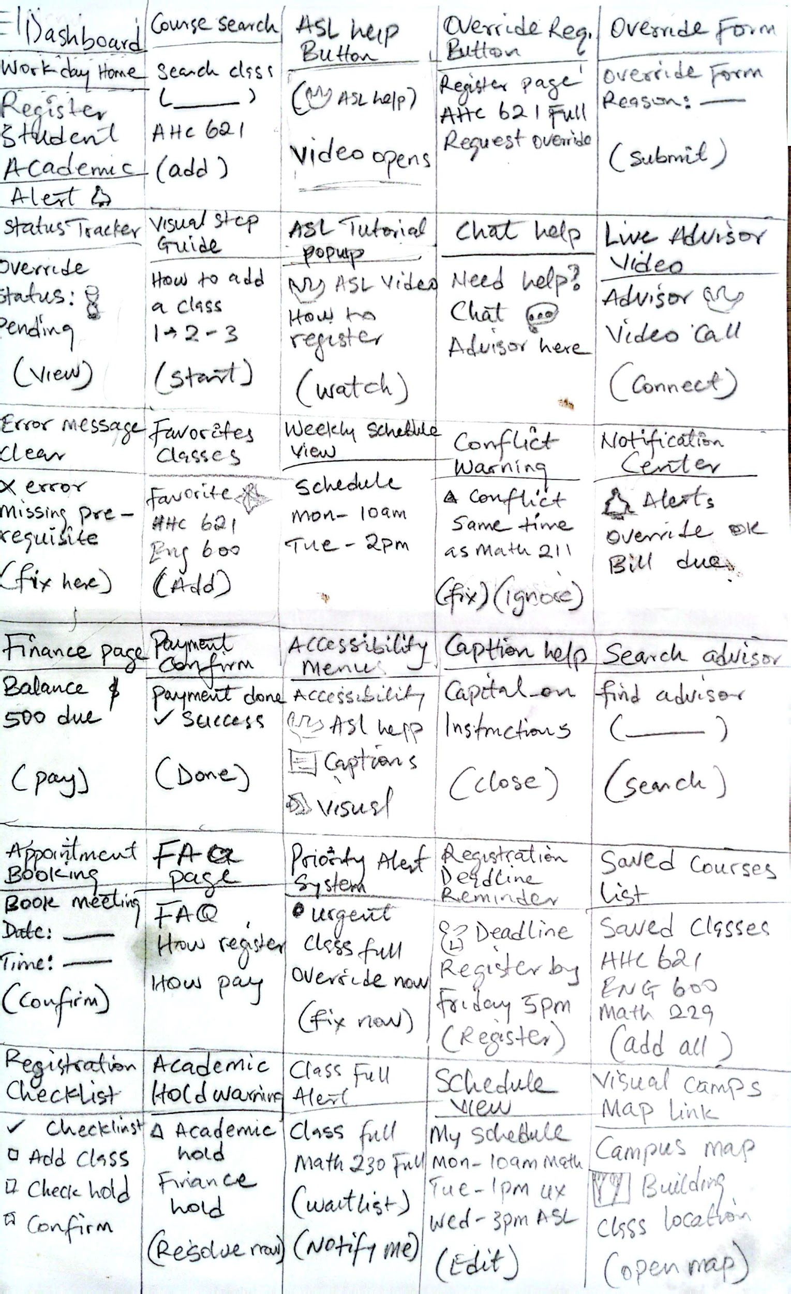Part 2: Converging Concepts - The Top 3
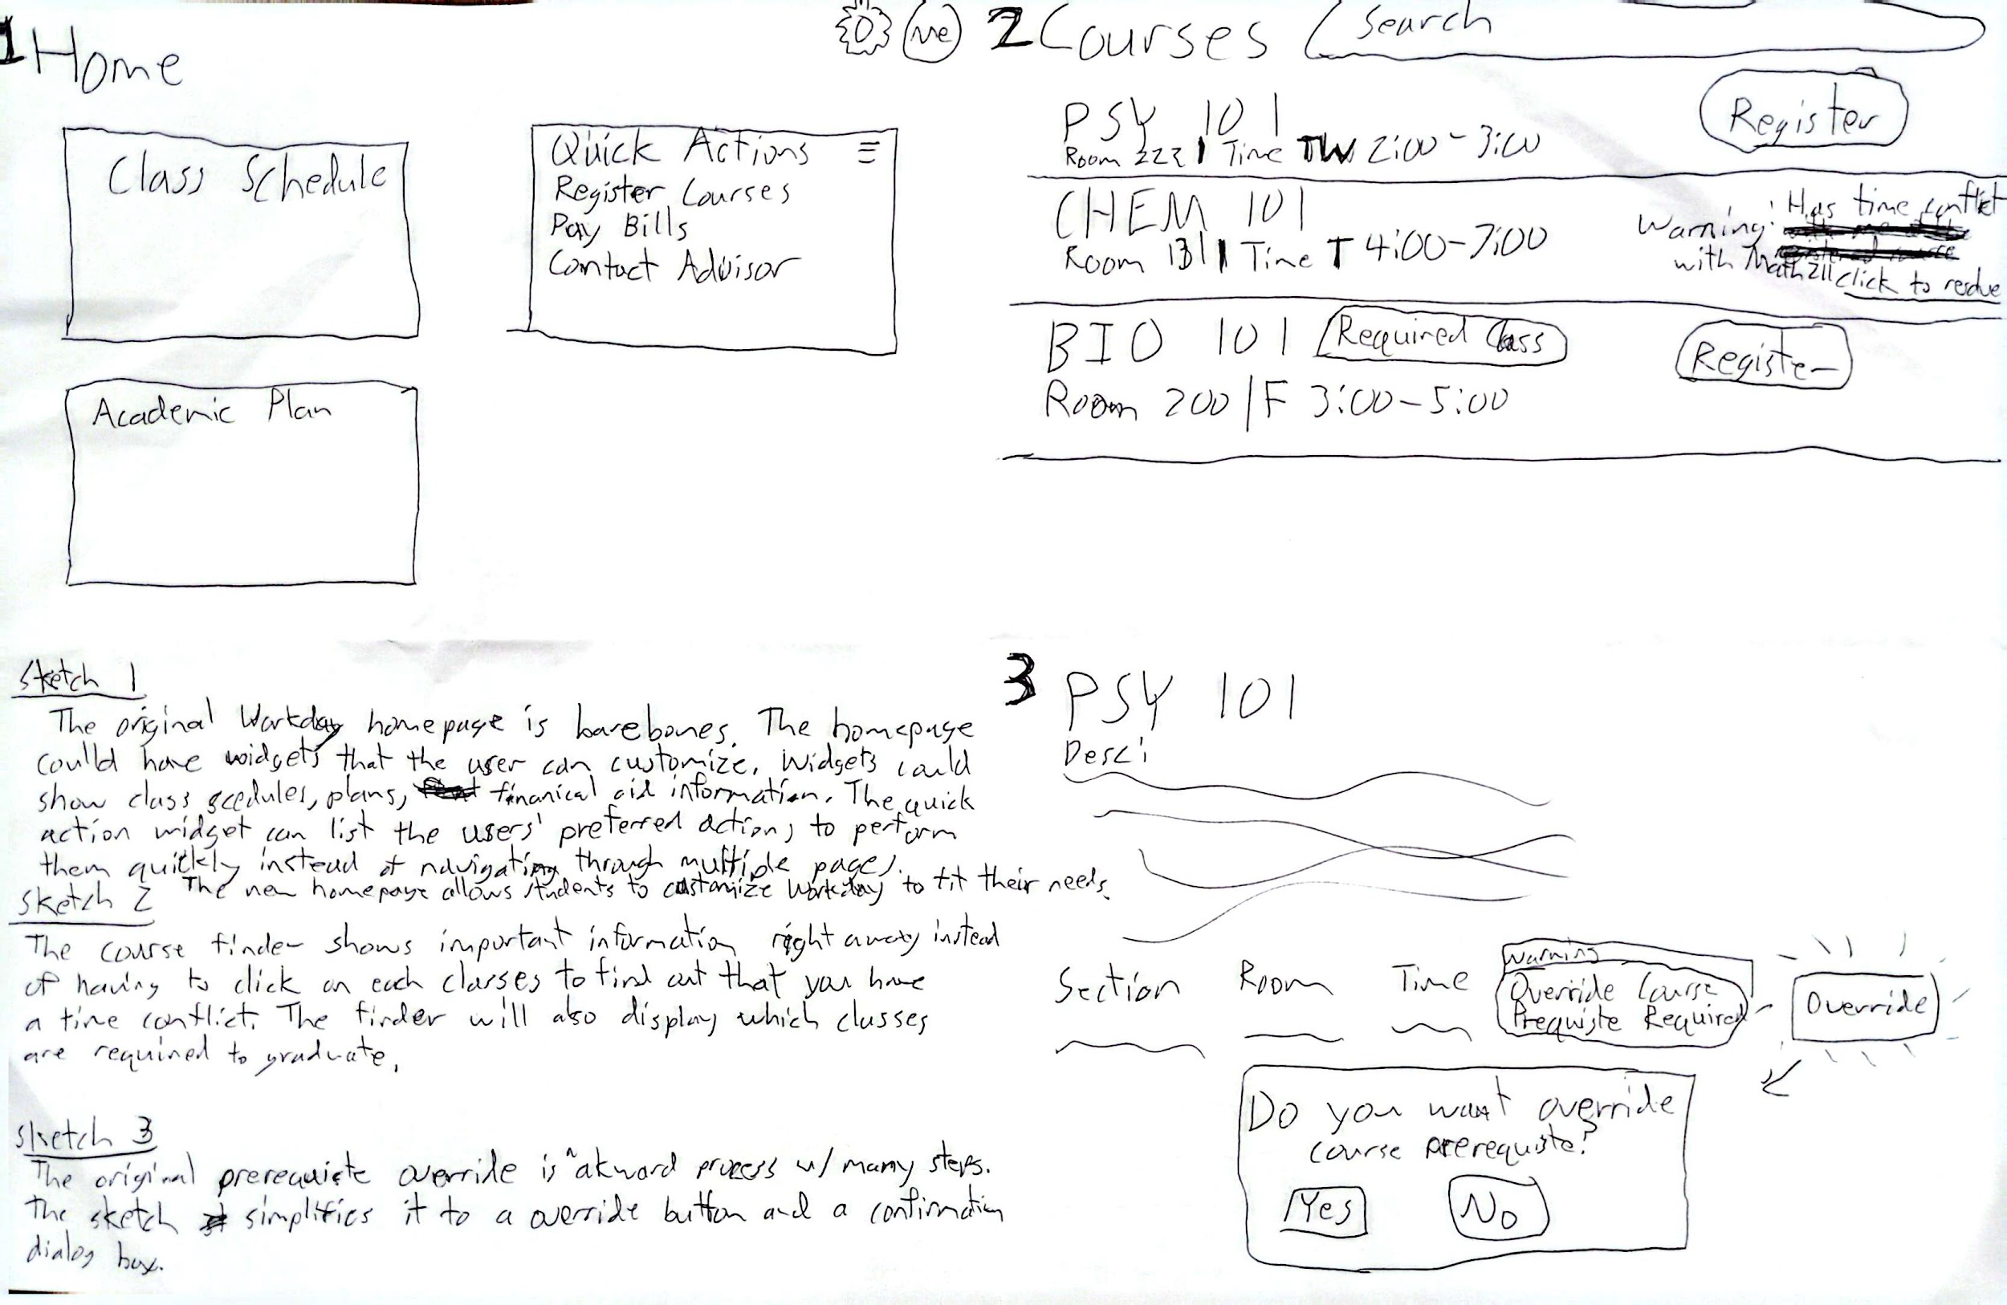
Sketch 1:
The original Workday homepage is barebones. The homepage could be improved by adding widgets to display important information such as class schedule, planned courses, financial aid information, etc. The homepage has a quick action widget that the user can customize to help them perform frequent actions to save time having to navigate the website. The overall goal of this sketch is to flesh out the homepage and provide customizability enabling users to make Workday fit their needs.
Sketch 2:
The course finder page displays important information that the user needs to know, such as if the course is required, has a time conflict, or needs a prerequisite override. The original course finder did not display these information, thus forcing students to do more work, such as keeping track of what courses are required, which has time conflicts. The overall goal of this idea is to reduce the cognitive overload of keeping track of various important information.
Sketch 3:
This sketch shows a simplification of one of the course registration processes, requesting course prerequisites override. The course information page has an override button that opens a dialog box to confirm the request. Unlike the original Workday, the user does not have to leave the course page and navigate to another webpage to complete the request. Instead, the whole process is done on one page. Simplifying class registration processes is one of our biggest priorities.
Part 3: Converging Concepts - One Sketch To Rule Them All
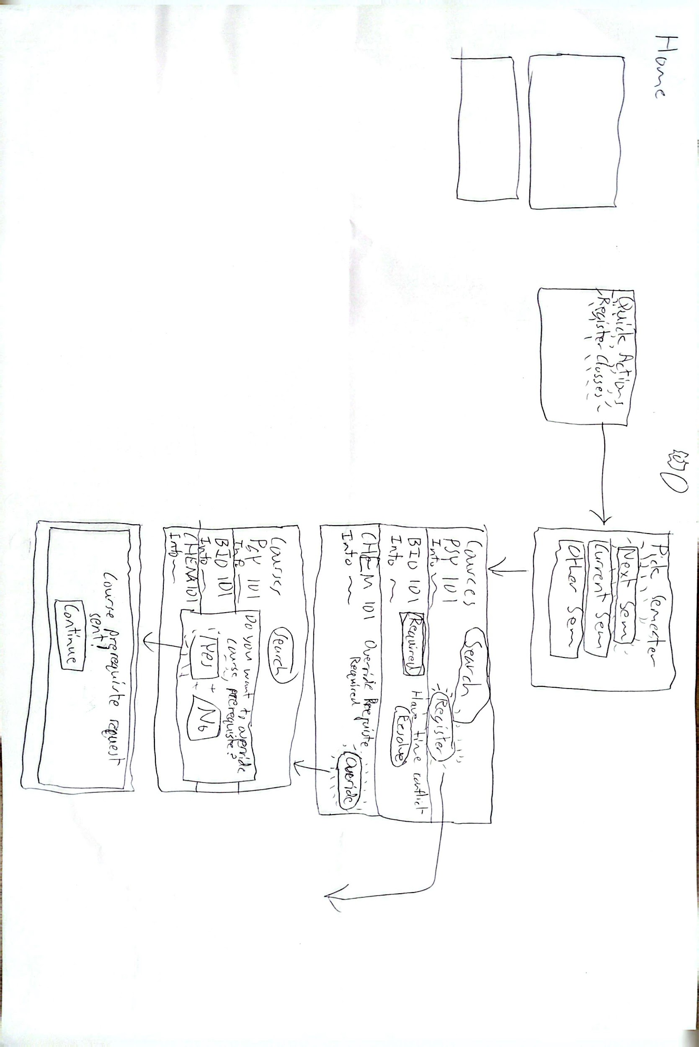
The final idea combines our three top three ideas. The overall primary idea is to reduce the number of steps required to register for classes. The sketch shows how we get from the homepage to the prerequisites override. The idea evolved from various sketches related to course finder. The sketches showed ideas for showing required class, time conflict information. One of the sketches showed a widget style homepage. Another showed a simplified prerequisite override process. From the 60 sketches, we prioritized what we need to improve Workday on: homepage, course finder, and simplification of registration process. The final idea combines the three top ideas to show how these ideas can be put together to show our class registration workflow. The final sketch shows the steps to make an override request.
Our primary users are students. From their perspective, they want to have a smooth and efficient experience using class finder to look up and register classes. Thus, simplifying steps is essential to our project. The quick action widget enables users to shortcut steps to get to the webpage they want to be on. The semester picker shows three buttons with the top two buttons linking to the semesters the students care more about: next and current semester. The bottom button is for other semesters. The original interface listed all of the semesters from oldest to newest, starting from 1982. You had to scroll all the way down to select recent semesters, which is inefficient and confusing. The next step shows the class finder page that shows classes with various issues. The appropriate button label is shown, register, resolve, override, to show what action will happen when we press them. You can see the problems and if the classes are required without having to click on each individual classes. When we press on the “Override” button, it opens a dialog confirmation box that allows us to submit an override request by pressing “Yes”. After that is done, the box will display a confirmation message that lets the user know the request is complete. All of this action is done without having to leave class finder, so we continue looking up more classes.

